Fiske Elementary School Family Ski Trip
March2-4, 2018
Room Blocks are being held at Golden Eagle and Town Square Condos- both are within a quick walking distance to Town Square and on the shuttle route to the ski resort. To secure your lodging, please reference FISKE ELEMENTARY SCHOOL when calling to reserve the rooms/units. There are limited rooms available, so please lock in early to ensure availability. We will send out a separate form for lift tickets, ski school, rentals, and lunch vouchers in the coming weeks.
Town Square Condos (www.waterville.com/lodging)- reserve by calling 1-800-GO-VALLEY and referencing FISKE ELEMENTARY SCHOOL for discounted rates:
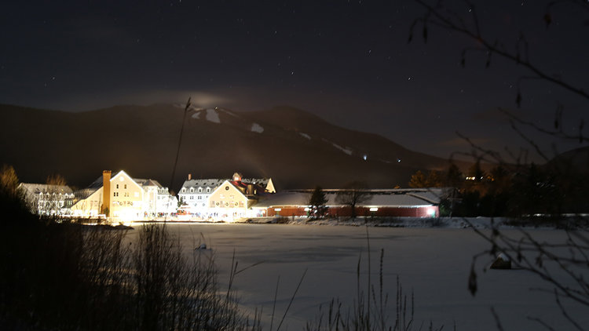
2 Level Condo (3 bedroom) $354 per night (inclusive of tax and resort fee)
3 Level Condo (3+bedroom) $376 per night (inclusive of tax and resort fee)
Resort fee includes FREEDOM PASS- access to the White Mountain Athletic Club (pools, jacussi, gymnasium), access to the Waterville Valley Indoor Ice Arena, Waterville Valley Recreation Department open gym activities including climbing wall, basketball, and any activities scheduled during your stay, access to the Curious George Cottage with story time and complimentary shuttle use) Condos can be shared by two families and include full kitchen and multiple bathrooms! 3 level units have bedroom with multiple twin beds- including bunkbeds!

Golden Eagle Resort (www.goldeneaglelodge.com)- reserve by calling 1-888-703-2453 and reference FISKE ELEMENTARY SCHOOL for discounted rates:
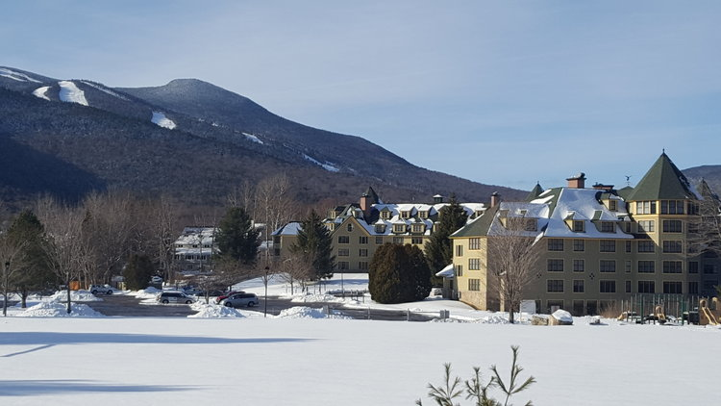
$271.56 per night (includes tax and resort fee) for a sleep 6 1 bedroom unit. Room configurations vary, other larger units available at additional rate- inquire when calling to reserve.
Resort fee includes FREEDOM PASS- access to the White Mountain Athletic Club (pools, jacussi, gymnasium), access to the Waterville Valley Indoor Ice Arena, Waterville Valley Recreation Department open gym activities including climbing wall, basketball, and any activities scheduled during your stay, access to the Curious George Cottage with story time and complimentary shuttle use)
Golden Eagle Resort is located a very brief walk from Town Square.
Both hotels are within brief walking distance to the Fiske Elementary School Family Ski Trip Saturday night dinner at Brookside Room in Town Square. Fireworks (weather permitting) will be at 7:30 on Saturday night.

